Citation: Misbah Rana Muhammad Ashraf, Faiza Farooq, Sumiya Arshad, Rabia Ashraf, Muhammad Nawaz Anjum, Mehreen Fatima, Syed Muhammad Yousaf Farooq, Zahid Siddique. Sonographic correlation of umbilical cord and umbilical vein diameter with fetal weight. IJNMS. 2024; 3(3): 8-12.

Estimating fetal weight is an important step for smooth and easy delivery the fetus, as approximation of fetal weight is necessary to plan the mode of delivering the baby thus facilitating the process both for the mother and the child. To correlate the method of predicting weight of the fetus by umbilical cord and its vein diameter. It was a cross sectional analytical study directed at The University of Lahore Teaching Hospital. The study was taken place for 12 months for which 200 women in their antenatal period were recruited. Convenient sampling technique was used and surveyed up to the date of delivery for actual weight at time of the birth. Paired t-test and the regression analysis was applied. The study concluded that the umbilical cord and the vein diameter serve as the major contributory factors in the fetal weight estimation by sonographic method. These methods are more accurate and easier as compared to the other methods implemented in the clinical practice until a few decades ago. Therefore, there is a need that clinical practices are modified and fetal weight estimates are done by using the umbilical cord and vein diameter to achieve better health outcomes for both mothers and children by pre planning the delivery method based on weight estimation of fetus.

***Original Research***

**Sonographic correlation of umbilical cord and umbilical vein diameter with fetal weight**

Misbah Rana Muhammad Ashraf*, Faiza Farooq, Sumiya Arshad, Rabia Ashraf, Muhammad Nawaz Anjum, Mehreen Fatima, Syed Muhammad Yousaf Farooq, Zahid Siddique

University Institute of Radiological Sciences and Medical Imaging Technology, Faculty of Allied Health Sciences, The University of Lahore

**International Journal of Natural Medicine and Health Sciences**

***ISSN (Online):2790-2471 ISSN (Print): 2790-2463***

**Volume 3(3) June 2024**

Journal homepage:https://journals.iub.edu.pk/index.php/ijnms



**Abstract**

Correspondence:

misbarana4@gmail.com

Keywords: Fetal Weight, Umbilical cord, Umbilical vein, Birth weight, Hadlock method





**Introduction:** Ultrasound is used to assess the growing and progress of the fetus all through the pregnancy. Any deviation from the normal growth in terms of growth retardation or over growth is picked by the ultrasound helping both the physician and the mother to work towards the underlying cause and to plan management method. Fetal growth is primarily assessed by estimating the fetal weight with Hadlock method according to percentile chart characterizing the fetus as normal, small or large for gestation1,2. To deal with the labor and delivery, it is necessary to estimate fetal weight accurately 3 as greater weight may lead to the complications both in mother and neonate 4. Similarly, babies who are born with low birth weight may suffer from respiratory distress, hypothermia and repeated infections. Fetal birth weight estimation can be done be using different sonographic equations. Fetal biometry (obtained by using ultrasonography) is a modern method which can be used to assess fetal weight. The benefit of this technique is that it proceeds linear and / or planar dimensions of the proportions of the fetus inside the uterus which are objectively commendable and should be able to reproduce5. Most commonly, hadlock equation is in use to determine the fetal weight. The latest version of this equation is Hadlock et al, E12 and calculated as Log10 Birth Weight = 1.3596 + 0.0064(Head Circumference) + 0.0424(Abdominal Circumference) + 0.174(Femoral Length) + 0.00061(Biparietal Diameter) (Abdominal Circumference) – 0.00386(Abdominal Circumference) (Femoral Length). This calculation uses different measurement such as (Abdominal Circumference), (Femoral Length), (Biparietal Diameter), and (Head Circumference). The Sensitivity and the specificity of this equation in predicting small for gestational age is 80% and 84% respectively7. However it was observed in previous studies that ultrasound reported a lot of overestimated low birth weight and underestimated high birth weight with this method. But it is still the commonly used technique considering that there is no other method to estimate fetal weight with greater accuracy.

Recent studies observed that calculations of umbilical cord and its vessels have important role in deciding both normal and abnormal outcomes as it is involved in fetal metabolism. There are numerous studies which consider umbilical cord thickness, Wharton’s jelly, cross sectional area, and the relationship between biometry and estimated weight of fetus, with only few studies available on umbilical cord diameters. This relationship between fetal weight and cord biometry if established will be helpful in cases when hadlock formula may have estimation faults mainly secondary to erroneous fetal head measurements

Fetal birth weight is an important indicator of the intrauterine growth8. This study intends to clarify relationship of estimated fetal weight with umbilical cord diameter and its vein diameter. The study was also establishing whether umbilical cord and its vein diameter are supportive in estimating fetal weight in condition of abnormal cephalic index where Hadlock formula shows estimation error and make recommendations to bring modification in clinical practices.

**Objective:**

To correlate the method of predicting weight of fetus by umbilical cord and its vein diameter.

**Methodology:** It was cross sectional analytical study directed at The University of Lahore Teaching Hospital. The study was continued for 12 months for which 200 women in their antenatal period were recruited. Convenient sampling technique was used and the women was followed till the date of delivery for the actual birth weight. Paired t-test and the regression analysis was applied. Data was analysed by SPSS 25.0. All quantitative variables like biparietal diameter, occipitofrontal diameter, circumference of head, length of femur, and circumference of abdomen was reported in mean ± S.D. Regression analysis was used to develop an equation for finding weight of fetus by using diameter of cord and diameter of vein. The difference between averages of expected Fetal weight (by cord and vein diameter) and actual birth weight was tested by paired t-test p- values<0.05 was considered as significant. Singleton fetuses from uncomplicated pregnancies, Accurate dating based on last menstrual period of women and first trimester ultrasonography of first trimester if available, No congenital anomalies; Appropriate for gestational age fetuses those are according to measurements by Hedlock formula; and No maternal disease (e.g., diabetes, hypertension). Gestational age 24-40 weeks as the ultrasonographic measurement become more accurate were included. Females with the history of gestational diabetes mellitus, Mothers with history of fever in first trimester, Females having history of irregular cycles were excluded.

**Results:** The regression equation was applied to estimate estimated fetal weight taking UCD as an independent variable. EFW(UCD) = 1.749 + 0.72 (UCD) with R = 0.241 and R2 = 0.058 with p-value = 0.013. No statistical difference was found between EFW by Hadlock and the new modal as p-value = 0.932. We also found no statistical difference between the fetal weight estimated by umbilical cord diameter (modal A) and actual birth weight estimated by Hadlock as p-value = 0.080> α = 0.05.The regression equation used to approximate estimated fetal weight taking UVD as independent variable EFW(UVD) = 0.982 + 0.144 (UVDless than 34 weeks) with R = 0.139 and R2 = 0.058 with p-value 0.013. No statistical difference was found between EFW by Headlocks and modal C estimated by umbilical vein diameter (UVDless than 34 weeks) as p-value = 0.986. We also found no statistical difference between new modal and actual birth weight as p-value = 0.050

**Discussion:** This research was led to establish relationships of sonographically estimated fetal weight with umbilical cord and umbilical vein diameter in the last trimester of pregnancy in local population settings. An overall 200 healthy pregnant females were encompassed in the research. Age of gestational and estimated weight was extracted by the ultrasound by means of the biparietal diameter, circumference of the head & abdominal area and the femur length (BPD, HC, AC and FL), noted with the aforesaid umbilical cord and vein diameter taken at a point in time. The statistical difference as on data analysis both for assessed fetal weight by formula of Hadlock and through cord diameter i.e. modal A and vein diameter for gestation below 34 weeks i.e. Modal C does not exist. As the p-valve is 0.013 for modal A and 0.013 for modal C. The association between the Hadlock and newly proposed method was stronger in model A and C. The relation was feebler and much weak when model B and D was taken as the weight doesn’t correlate if umbilical vein diameter of gestation age more than 34 weeks taken for approximation of weight of fetus. As in model B all the patients in last trimester including 34 weeks and above was included and in model D umbilical vein diameter of cases only more than 34 weeks was taken. As in another study correlation was stronger when gestation is less than 34 weeks but at gestation age more than 34 weeks’ umbilical vein diameter doesn’t remain as reliable tool for estimation of weight9 of fetus. There was no statistical difference for estimating fetal weight by Hadlock formula and umbilical cord diameter by p-value as 0.013 as in Modal A. But there was some statistical difference of estimated weight by Hadlock formula and umbilical vein diameter above 34 weeks as p-value was 0.986 as in Modal D. So the diameter of umbilical cord could be a variable for the estimation of weight of fetus in pregnancy but umbilical vein could not be the variable for estimating fetal weight for above 34 weeks. As described similarly by other authors Aydin Kosus et al9. After further studies and progress in this aspect the nomograms could be set for particular diameters of umbilical cord to estimate fetal weight 10. Similar results was seen and nomograms were made by an Israel’s research where nomograms were made for cord diameter and its vessels diameter. Which engrossed mainly on predicting nomograms after deriving regression equation for cord vein and artery diameter. Regression equations for the diameter of cord reported by age of gestation (GA) is Y = -9.245 + 1.36 GA - 0.017 GA2 (r = 0. 99), for the diameter of the umbilical vein Y = - 6.9 + 0. 72 GA - 8.8 x 10- 3 GA2 (r- 0.994), and for the diameter of umbilical artery y = -1.98 + 0.25 GA- 2.4 x to-3 GA2 (r-= 0.986). The regression curve for the surface area of Wharton's jelly according to gestational age is given by Y "" -260.3 + 23.6 GA - 0.323 GA2. according to Amir Weissman et al isreali population 11. The foremost study in the above-mentioned field was in 1994 and it stated that the umbilical cord diameter and its vessels diameter i.e umbilical veins and umbilical artery advances with gestational age till 32 weeks succeeded by a plateau 12. The second study obtained reference ranges for umbilical cord diameter and CSA and showed that these values rise with gestational age until 32 weeks and relate with fetal size13.Togni et al. found the same outcome, but the values augmented up to 33 weeks 14. In an Iranian research we found a noteworthy increase in the CSA and circumference of the umbilical cord, umbilical vein and umbilical arteries during pregnancy. There is a significant consistent increase in the CSA of the umbilical cord, the area of umbilical vein and the CSA i.e cross sectional area of Warton Jelly during prenatal period till 30 weeks15. Nevertheless, the outcomes of our study support preceding observations and it could be due to the strong correlation that be present. Therefore, dimension of umbilical cord parameters is highly suggested in the routine prenatal sonography 5.

**Conclusion:** The study concluded that umbilical cord and the vein diameter serve the main function in predicting the fetal weight and delivery outcomes. This can help the health care professionals in deciding the mode of the delivery while simultaneously helping the pregnant mothers to know about the growth status of the fetus and subsequent outcomes of the pregnancy

**References**

1. Mlynarczyk M, Chauhan S, Baydoun H, Wilkes C, Earhart K, Zhao Y et al. The clinical significance of an estimated fetal weight below the 10th percentile: a comparison of outcomes of <5th vs 5th–9th percentile. American Journal of Obstetrics and Gynecology. 2017;217(2): 198.e1-198.e11.

2. Superville S, Siccardi M. Leopold Maneuvers. 2021;

3. Ugwa EA. Advances in clinical estimation of foetal weight before delivery. Niger J Basic Clin Sci 2015; 12:67-73

4. Berard J, Dufour P, Vinatier D, Subtil D, Vanderstichele S, Monnier J, et al. Fetal macrosomia: risk factors and outcome: A study of the outcome concerning 100 cases> 4500g. European Journal of Obstetrics & Gynecology and Reproductive Biology. 1998;77(1):5

5. Bossak W, Spellacy W. Accuracy of estimating fetal weight by abdominal palpation. The Journal of reproductive medicine. 1972;9(2):58-60. R

6. Zhang J, Merialdi M, Platt L, Kramer M. Defining normal and abnormal fetal growth: promises and challenges. American Journal of Obstetrics and Gynecology. 2010;202(6):522-528.

7. Chandrashekhar Y, Alexander T, Mullasari A, Kumbhani DJ, Alam S, Alexanderson E, et al.Resource and infrastructure-appropriate management of ST-segment elevation myocardial infarction in low-and middle-income countries. Circulation. 2020;141(24):2004-25.h

8. Roland M, Friis C, Voldner N, Godang K, Bollerslev J, Haugen G et al. Fetal Growth versus Birthweight: The Role of Placenta versus Other Determinants. PLoS ONE. 2012;7(6):e39324.

9. Kosus A, Kosus N, Turhan NO. Is there any relation between umbilical artery and vein diameter and estimated fetal weight in healthy pregnant women?. Journal of Medical Ultrasonics. 2012 Oct;39(4):227-34.

10. Barbieri C, Cecatti JG, Surita FG, Marussi EF, Costa JV. Sonographic measurement of the umbilical cord area and the diameters of its vessels during pregnancy. Journal of Obstetrics and Gynaecology. 2012 Apr 1;32(3):230-6.

11. Weissman A, Jakobi P, Bronshtein M, Goldstein I. Sonographic measurements of the umbilical cord and vessels during normal pregnancies. Journal of ultrasound in medicine. 1994 Jan;13(1):4-11

12. Weissman A, Jakobi P, Bronshtein M, Goldstein I. Sonographic measurements of the umbilical cord and vessels during normal pregnancies. Journal of ultrasound in medicine. 1994 Jan;13(1):11-4.

13. Raio L, Ghezzi F, Di Naro E, Gomez R, Franchi M, Mazor M, Brühwiler H. Sonographic measurement of the umbilical cord and fetal anthropometric parameters. European Journal of Obstetrics & Gynecology and Reproductive Biology. 1999 Apr 1;83(2):131-5.

14. Togni FA, Júnior EA, Moron AF, Vasques FA, Torloni MR, Nardozza LM, Filho HA. Reference intervals for the cross sectional area of the umbilical cord during gestation.

15. Rostamzadeh S, Kalantari M, Shahriari M, Shakiba M. Sonographic measurement of the umbilical cord and its vessels and their relation with fetal anthropometric measurements. Iranian Journal of Radiology. 2015 Jul;12(3). 24

|  |  |  |  |  |  |  |  |
| --- | --- | --- | --- | --- | --- | --- | --- |
| **Table 1.** Descriptive Statistics | | | | | | | |
|  | N | Range | Minimum | Maximum | Mean | | Std. Deviation |
| Statistic | Statistic | Statistic | Statistic | Statistic | Std. Error | Statistic |
| Gestational Age | 105 | 18.29 | 22.71 | 41.00 | 34.5361 | .30873 | 3.16357 |
| UMBILICAL CORD DIAMETER (mm) | 105 | 14.50 | 8.00 | 22.50 | 15.6980 | .28109 | 2.88027 |
| UMBILICAL VEIN DIAMETER (mm) | 105 | 13.20 | 5.00 | 18.20 | 9.2148 | .20790 | 2.13036 |
| UCD (cm) | 105 | 1.45 | .80 | 2.25 | 1.5698 | .02811 | .28803 |
| ESTIMAID FETAL WEIGHT | 105 | 4.70 | .80 | 5.50 | 2.8724 | .08345 | .85507 |
| ACTUAL BIRTH WEIGHT | 105 | 33.00 | 1.40 | 34.40 | 3.4171 | .30455 | 3.12073 |
| N | 105 |  |  |  |  |  |  |

**Table 2.** Proposed modals for estimated fetal weight by umbilical cord diameter and umbilical vein diameter

|  |  |  |  |  |
| --- | --- | --- | --- | --- |
| **Modal** | **Variables** | **Modal** | **R2** | **p-value** |
| A | UCD (X) and EFW (Y) | EFW = 1.749 + 0.72 (UCD) | 0.058 | 0.013 |
| B | UVD (X) and EFW (Y) | EFW(UVD for entire last trimester) = 2.236 + 0.069 (UVD for entire last trimester) | 0.030 | 0.080 |
| C | UVD <34 (X) and EFW (Y) | EFW = 0.982 + 0.144 (UVDless than 34) | 0.139 | 0.013 |
| D | UVD >34 (X) and EFW (Y) | EFW =10.195 – 0.196 (UVD(greater than 34 GA)) | 0.003 | 0.663 |

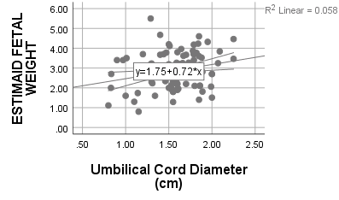

**Figure 1.** Umbilical cord diameter

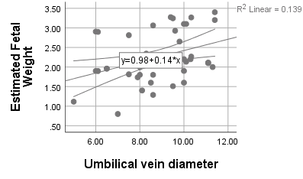

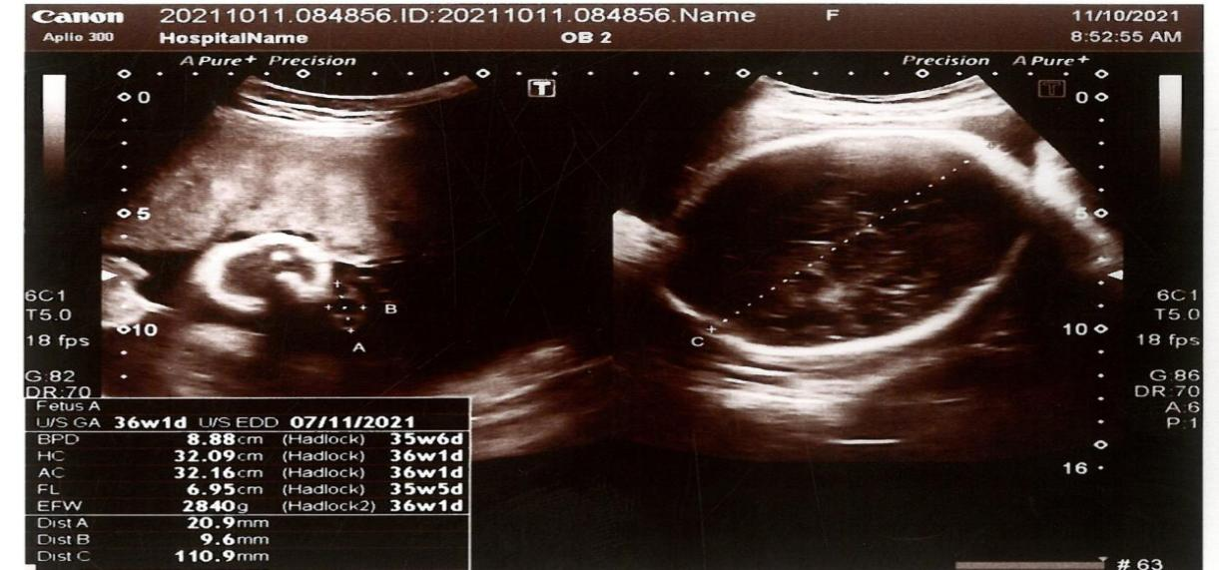**Figure 2.** Umbilical vein diameter

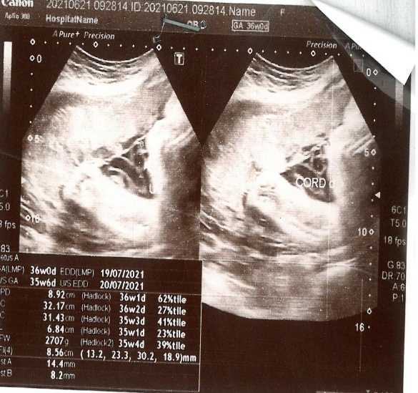**Figure 3.** The umbilical cord diameter in thisscan is 14.4 and diameter of umbilical vein is 8.2 at 36 weeks of gestation

**Figure 4:** The umbilical cord diameter in thisscan is 14.4 and diameter of umbilical vein is 8.2 at 35 weeks 6 days of gestation