|  |  |
| --- | --- |
|  | Volume and Issues Obtainable at the Department of Tourism and Hospitality Management- The Islamia University of Bahawalpur, Bahawalpur, Pakistan 63100.  **Journal of Tourism, Hospitality, and Services Industries Research**  ISSN: 2958-5570 ; ISSN (E): 2958-5589  Volume 5, No.1, June 2025  Journal homepage: [https://journals.iub.edu.pk/index.php/jthsir](https://journals.iub.edu.pk/index.php/jthsirs)  DOI: 10.52461/jths.v5i01.3821 |

**Urban Mobility Overview of Pakistan: Focus on Islamabad**

**Sidra Jawad\***, *Quaid-e-Azam University Islamabad, Pakistan*

**Muhammad Zaman**, *Quaid-e-Azam University Islamabad, Pakistan*

|  |  |
| --- | --- |
| **ARTICLE DETAILS** | **ABSTRACT** |
| **History**  Received: May, 2025  Online: July, 2025  **Keywords**  *Mobility, congestion, road safety, urbanization, Islamabad* | The economic growth of a country is dependent upon road infrastructure. But due to urbanization, the majority of cities, including Islamabad, are facing issues of mobility. Therefore, this study was designed to explore factors that can help in improving the mobility of people in Islamabad. This research identified key traffic issues of Islamabad through literature analysis of past studies. In the end, this research also recommended a few strategies to improve traffic issues of Islamabad. This research is beneficial for policymakers to improve traffic issues in the capital of Pakistan. Also, future studies can use these findings for future studies |
|  | © 2025 The authors, under a Creative Commons Attribution Non-Commercial 4.0 |
| *\*Corresponding author:* [*sidrajawad92@gmail.com*](mailto:sidrajawad92@gmail.com) | |

**Introduction**:

Urbanization creates several issues for cities. These issues and problems include political instability, social inequality, epidemic diseases, pollution, and urban flooding. Therefore, it is very important to study the sustainability of urban growth. It has an important role in the decision-making of urbanization. These steps play a significant role in improving the quality of the environment, prevention, disaster monitoring, poverty reduction, and construction programs. Cities are getting denser, and they continue to become denser with the passage of time (Zeng, Wang, Zhang, Sun, & Santibanez Gonzalez, 2021). A number of challenges are being faced by decision-makers and planning departments because of these new issues. Among the mentioned challenges, the sustainability of transportation is a key issue. These challenges play an important role in the development process of urbanization (Ma, Guo, Yuen, Woo, & Shi, 2019).

The economic performance of the country is also dependent upon the mobility of efficient urbanization. It also ensures soft justice, poverty alleviation, happiness, harmony, and the overall uplift of society (Mascarenhas, Haase, Ramos, & Santos, 2019). It plays a key role in the development of plans and policy integration so that urban development and its sustainability can be achieved. It is acknowledged by the community that the planning of urbanization has a very important role in the sustainable development of cities. They also recognize that cities face a number of challenges due to urbanization because multiple opportunities are offered by the urbanization process at the global level. The main goal of the urbanization process is to make cities sustainable, resilient, safe, and accessible for human beings (Abubakar & Aina, 2019).

Transport is a key component of human welfare and the economic development of the country. Therefore, transportation activities are increasing at the global level, as they directly impact economic growth. However, there are a number of challenges associated with the growth of traffic (Pasquale, Sacone, Siri, & Ferrara, 2019). One of the challenges is traffic accidents, because of which people lose their lives or are injured. On the other hand, problems like petroleum consumption, air pollution, and congestion are also caused by traffic. An important thing to note is that these problems are being faced in countries or cities that are growing economically at a fast pace. Mitigating these issues is one of the big challenges (Cheng, Pang, & Pavlou, 2020).

At the global level, traffic congestion is increasing. Both developing and developed countries are facing this issue equally. If this issue is not solved as a priority, the situation will worsen. It has a major impact on traffic flow interruption, environmental pollution, operational costs, fuel consumption, and an increase in journey time. All stakeholders of the city are affected in a negative manner, as the quality of life is negatively impacted in terms of noise pollution and air pollution (Z. I. Zafar, Anjum, Anjum, Iftikhar, & Manzar, 2015). On the other hand, it has a negative impact on the sustainability of economic activities and the health of the people. Therefore, it is very vital to control congestion (Afrin & Yodo, 2020).

The problem of congestion is caused by the excessive use of automobiles, even when it is not necessary. There are a number of benefits to using private cars, including a sense of security, status symbol, and ease of mobility. Although they are not efficient means of transport, people still prefer to use them because of comfort. It causes 11 times more travel time for passengers compared to the use of buses. This situation becomes worse due to poor road design, driving style, the way roads are used, and lack of city maintenance. On the other hand, some studies have also reported issues of unsustainable management, faulty mechanisms for providing information, and lack of technology as causes of road congestion (Jin & Rafferty, 2017).

Past studies have also reported that urban transportation plays a significant and fundamental role in economic and trade growth and leads toward sustainable development. It is key to note that the cost of congestion to be paid by people is very high.(Wang, Xue, Zhao, & Wang, 2018). According to studies and reports, congestion creates or increases the average journey time of private cars by 1 kilometre per hour. It also leads to a reduction in journey time (Alvarez, Lerga, Serrano-Hernandez, & Faulin, 2018).

The results of the digital census were approved this year by the Government of Pakistan. According to the digital census, the total population of Pakistan is 241 million, and it is increasing at a rate of 2.5% per annum. In terms of South Asia, Pakistan has a very strategic role along with India and China. Its strategic location is significant because a number of important countries are neighbors of Pakistan (Rehman, Ma, Ozturk, & Ulucak, 2022). Also, Pakistan has Arabian Sea that gives access to waters as well.

The population of Pakistan is also increasing at a very fast pace. It is estimated that almost 70% of the people in Pakistan will be living in cities in the next 25 years. Cities are the drivers of the economy, and they contribute around 80% to the global economy. This contribution is affected by urbanisation. In the context of Pakistan, urbanisation is one of the fastest processes. The annual growth rate of urbanisation in Pakistan is 3% (Zahir, 2023). One of the reasons for urbanization in Pakistan is rural-to-urban migration. On the other hand, the natural increase in city populations is also causing urbanization in Pakistan. Presently, 36% of people in Pakistan live in cities. It is expected that this figure will reach 50% in the next two years. With this massive urbanization, there is increasing pressure on urban infrastructure such as public utilities, transportation, power, education, health, and housing (Rana, Bhatti, & Arshad, 2017).

This growth in urbanisation has created pressure on the transportation system of Pakistan. The existing road networks in Pakistan are not enough to accommodate the growing number of vehicles. It is also not possible for most people to afford personal vehicles. Therefore, they prefer public transport. However, there are a number of issues with public transport in Pakistan. Because of these transportation issues, people face problems such as delays and hassle when traveling. On the other hand, the increase in vehicle usage has significantly impacted fuel consumption. It has negatively affected the environment and air quality (Tariq & Waheed, 2023). Because of these challenges, it is evident that the transportation system in Pakistan is not sustainable, and it forces policymakers to adopt policies and strategies that can make this system sustainable. The basic purpose of this research is to highlight the core issues of the transportation system in Pakistan with the aim of developing strategies that can improve the sustainability of transportation and the environment.

**LITERATURE REVIEW**

As per the data published by the Planning Commission of Pakistan, more than 100 million people of Pakistan are living in urban areas. Around 66% of this population is living in 10 big cities. These cities are becoming tougher places to survive and live big cause of alterations in functional and organisational characteristics of urban areas. These localities are becoming crowded because of which has a negative impact on the living quality of the cities. The average income of Pakistani people is also decreasing. In this situation, it becomes difficult for a layman to afford a car. Therefore, most people have to rely on public transport for their daily purposes (Jabeen, Farwa, & Jadoon, 2017).

Since 1980, the public transport system of Pakistan has been deregulated. Since that time, the urban transport system has been run by private organisations in the cities. The fare of these transports is controlled by the government. On the other hand, the government also control licensing of the route as well. These private transporters prefer maximisation of profit by lowering the cost of their operations (M. H. Baig, Waheed, Rana, & Abbas, 2022). The efficiency and quality of transportation are compromised in this way, as the turkeys are unable to control it. They have failed because they don't have the capacity to supervise the private business owners of the transportation sector (Adeel, Yeh, & Zhang, 2016).

This situation is worse in the context of Pakistan. According to statistics, Pakistan is ranked 95th globally in terms of road safety. Moreover, around 18 people lose their lives among 100,000 people the cause to road accidents. Moreover, it is also estimated that around 10 people in Pakistan lose their lives daily because of road accidents. The rate of road accidents is estimated at around 100 billion annually. It is interesting to note that two winners and pedestrians are more involved in road accidents in big cities like Hyderabad, Quetta, Rawalpindi, and Islamabad. Karachi and Lahore (F. Baig, Shaikh, & Talpur, 2021).

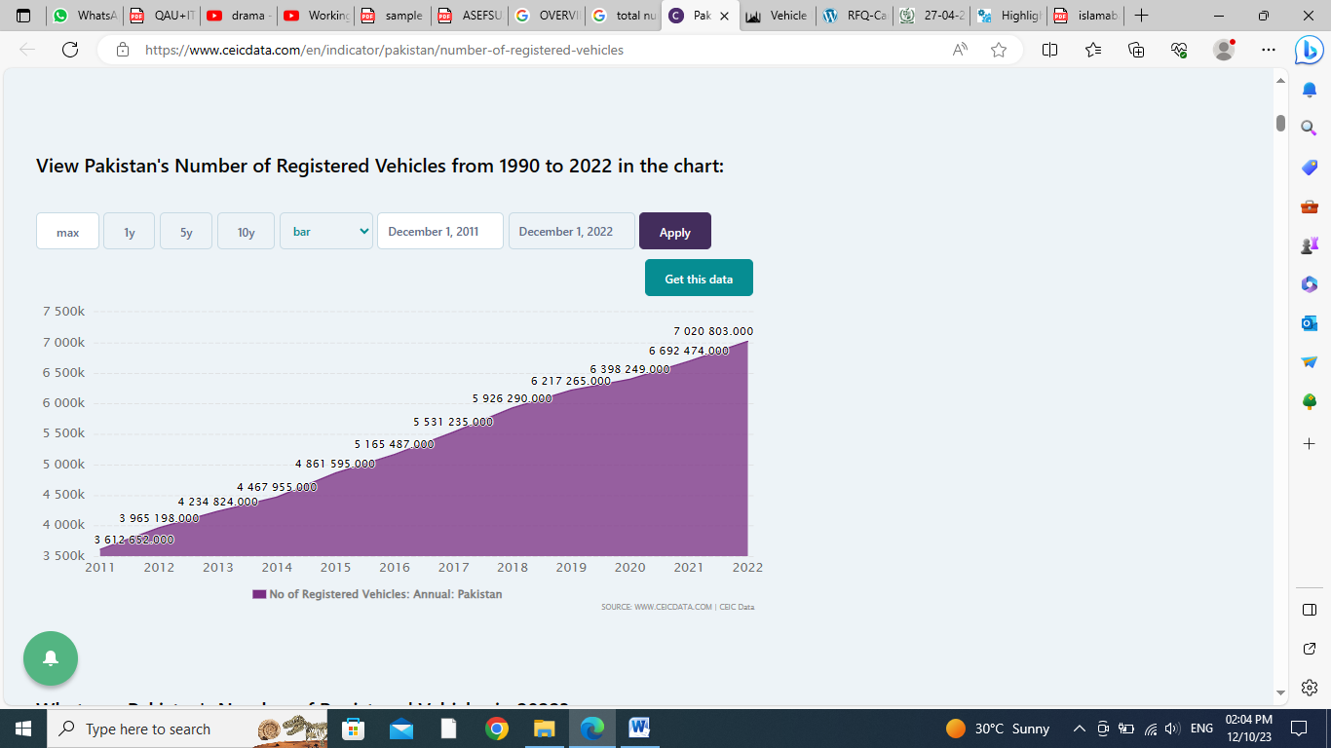

Source: (CEIC, 2022)

**STUDY AREA**

The geographic area that was the focus of this study was Islamabad. This city was given the status of the capital city of Pakistan in 1960. The geographical area office in Islamabad is 906.5 sq. KM, which is 25% of the urban area. A number of planning departments are involved in the urban and road network planning of this city. Some of the studies have reported that Islamabad is one of the best network cities in terms of roads.

**OVERVIEW OF THE TRANSPORTATION SYSTEM IN ISLAMABAD**

Islamabad is one of the largest metropolitan cities of Pakistan. Ask for the information available. More than two million people live in this city. It is ranked as the tenth most populous city in Pakistan. It is estimated that this city is growing at a rate of 4% annually. Some of the reports had mentioned that the population of Islamabad will reach 4 million in the next seven years as the growth rate will increase to 4.9% annually (Shah, Ali, & Nizami, 2022). Some of the studies have reported Islamabad as one of the most livable cities in Pakistan. The literacy rate of Islamabad is also very high, and there are a number of internationally and nationally top-ranked universities. This city also hosts the headquarters of a number of corporations (hidayat fahrul, 2023).

The initial master plan of Islamabad was developed in 1960 by Greek planners. Later, a number of efforts were made to update the plan. In this regard, a number of efforts have been made over the last 10 years to update this master plan. In the recent past, a Commission was established to update this master plan for the next 20 years. In this regard, it is planned by CDA to hire an international consultant firm so they can develop a comprehensive master plan (Hasan, Chaudhry, Ahmad, & Jalil, 2021).

**Major Stakeholders of Islamabad’s Transport System**

CDA is controlling major operations in Islamabad as it is the capital city. In order to regulate the transportation system, there are some departments and bodies. The table below represents the stakeholders of Islamabad who are responsible for infrastructure, operations, planning, and policies air transportation system of Islamabad. According to data available, there are 23 routes in Islamabad and around 1500 vehicles operating in this city on these routes.

***Table 1***

***Major Stakeholders of Islamabad***

|  |  |
| --- | --- |
| **Authority** | **Roles** |
| CDA | Maintenance, regulation, operations and Planning of urban transport |
| ITA | Issues and regulation of public transport routes |
| NTRC | Planning and Policy development regarding modes of transport |

***Table 2***

|  |  |  |
| --- | --- | --- |
| Detail | Route | No of vehicle |
| Islamabad | 24 | 1418 |

**Islamabad’s mode of Transport**

The transport system of Islamabad is currently comprised of Informal and formal modes of travelling. The authorised and formal mode is based on large buses, vans and private cars/ they are run by a bus rapid transit system known as BRT. It comprises 95% of the Islamabad transportation system. But this transportation system is facing the issue of low ridership in some of the Islamabad areas. Therefore, this transportation system had to be inactive in these areas (Rawalpindi & Kamran Ahmed, 2021).

Almost seven years ago, a new transportation company was introduced in Islamabad and Rawalpindi. Most of the market was captured by this company, add affected the ridership of cabs and taxis. Moreover, cheap ridership was also introduced in the form of motorcycles by this company. It covers the needs of low-income groups of people in Pakistan, more specifically in the Islamabad context. The business of public vehicles like Suzuki and HiAce is also negatively affected by these service providers (Naqvi, 2017). Five service providers are operating in Islamabad by providing riding facilities, as mentioned in the figure below

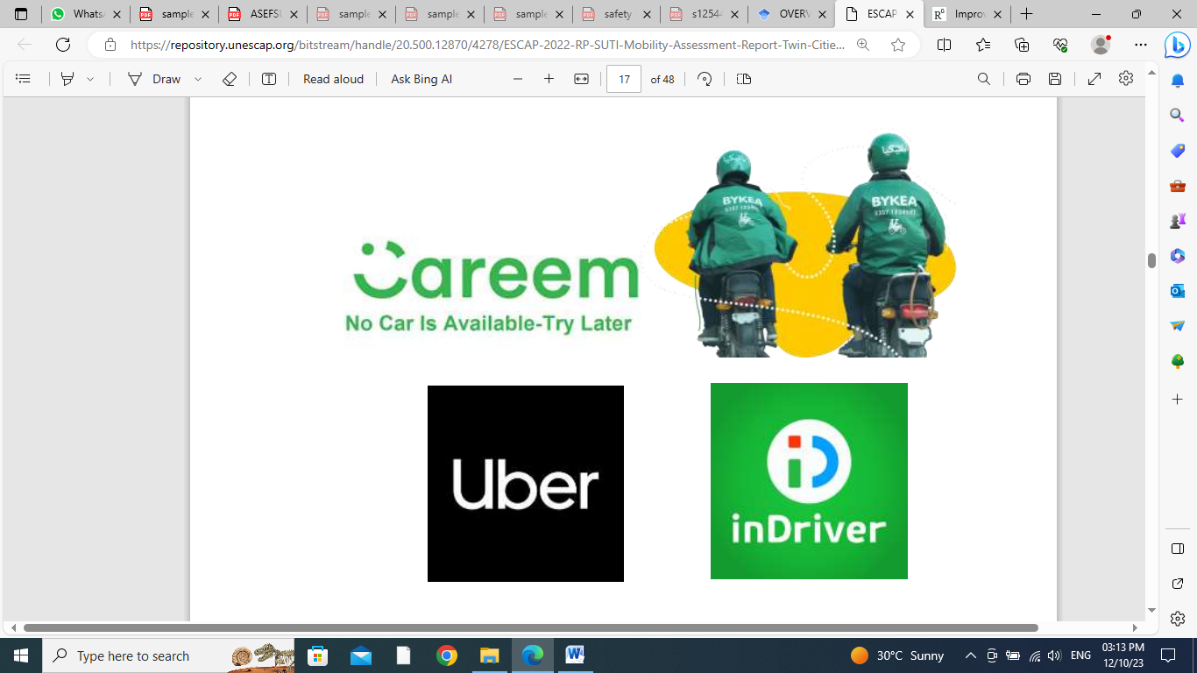

BRT started their operations in Islamabad in 2015. The area allocated for BRT was 24 kilometres. Presently, there are 24 buses operating on this route between Islamabad and Rawalpindi. Later, this route was enhanced, and also number of buses was increased as well. The structure of Islamabad is very unique. This structure supports the transportation sector. As a result, the need for travel is created as well. As per stats, more than 700,000 people travel by weather in Islamabad daily. In terms of trips there are 500,000 trips are planned daily within Islamabad and Rawalpindi. The level of congestion in Islamabad is getting worse day by day as the population of the city is increasing rapidly (Atif, Saqib, Ali, & Zaman, 2018).

The city of Islamabad is expanding regularly. This situation is creating a number of complex problems for people. The transportation demand is also increasing in Islamabad because of urban growth. This city mainly relies on the street system as compared to major roads or highways. This system is unfortunately over text and unable to meet the traffic demand of people. As a result, commercial traffic is becoming a problem for people living in Islamabad. In order to solve this issue, long-term and short-term strategy plans are required. Plans are also required to minimise the impact on environmental pollution as well (Haider, 2022).

**IMPORTANT MOBILITY PROBLEMS IN ISLAMABAD**

**Congestion**

The major mobility problems of Islamabad are mentioned in a number of studies. One of these problems is congestion. According to scholars, it is a phenomenon that is faced by people when the traffic demand is more than the capacity of the road network (Raza et al., 2022). This issue also reflects one of the key weaknesses of infrastructure. This issue creates delays, diminishing the efficiency of transport, impacting mental health and enhancement in operational cost of transport(N. Zafar & Haq, 2020)**.**

In Pakistan, the problem with traffic congestion is increasing and becoming very serious as well. The same is the situation in the city of Islamabad. People have to waste a lot of time due to traffic jams. The economic success of people is negatively affected because of traffic congestion. In busy hours, the traffic system becomes congested as well. This situation is faced in school areas, shopping malls, recreational centres, business hubs, metro stops and other public places. This situation becomes worse during officers' opening and closing times. Also, there is an issue of transportation amenities. These amenities include an outdated system of traffic management, parking layouts and signal control systems. These factors, along with other physical factors, contribute to congestion of traffic. The focus of people is on business trips or parcel deliveries when they're on the road. But due to road congestion, they're often late on their personal or private trips, even when they're using their vehicles as well(Ali et al., 2021)

**Mixed Use of Road Space**

A number of masses are using the roads of Islamabad for a number of reasons. The population of Islamabad is more than 2 million. Whereas the number of vehicles registered is more than 1.3 million. It indicates that the burden of vehicles on the road is very high. Soon, it will be very difficult for the roads to support this number of vehicles. Furthermore, the roads are also crowded, and the behaviour of drivers is very poor and aggressive as well. These drivers are not trained to drive the vehicles. Additionally, sometimes roads are also occupied by animals like cattle. The mobility of transport becomes difficult on this mixed-use road. Also, this situation creates road accidents as well (News, 2022).

**Parking Problems**

Islamabad is also facing the issue of parking, as there is very limited space for parking. This issue is getting worse in commercial areas. As a result, there is an issue of congestion on roads and illegal parking. It also leads to many other parking issues. The pressure on bikes and cars is increasing as a result, and space to drive these vehicles is shrinking (Pakistani, 2023). The parking space of plazas and markets is designed in order to benefit the shops. Whereas in the last two decades, the number of shops in Slough has increased along with the number of vehicles as well. As a result, the parking space is shortened (Abbasi, 2022).

**Inadequate Public Transportation**

Despite the fact that Islamabad own traffic transportation system, this transportation system is not well integrated. The frequency of buses and the coverage of buses are limited. In this situation, the public transport system becomes less attractive, and the reliance of people on private vehicles increases. There is a lack of connectivity in commercial centres and residential centres as well. As a result, it becomes difficult for people to rely on the public transportation system. Therefore, they look for alternative modes of transport (Chakar, 2023).

**Traffic Awareness**

There is a lack of awareness among the general public regarding the regulations and rules of traffic. It is one of the significant factors that contribute to road accidents. Traffic awareness is one of the major causes. Another cause of death during road accidents is the use of usage of phone during driving. According to the reports available but all 2 million people annually lose their lives at the global level as they use mobile phones while driving. It is not safe for drivers to use a mobile phone while driving. In the case of an emergency, they should stop the vehicle and attend to the call. It is very important to save the life of the driver and other people walking on the road (Shafi, 2023). For this reason, there is a need to create awareness among the media and traffic people. But in the context of Pakistan, these two institutes are not playing an adequate role. Strictness in enforcement is required for the regulations and laws, so this issue can be resolved.

**DISCUSSION AND CONCLUSION**

The transportation facility within a country plays a very important role in its development. It also impacts economic linkages. Business activities are ensured to be completed timely and safely because of a good transportation system. The safe travel of people is also dependent on this factor. People who are involved in business are always looking to cut costs. If the transportation system is good, it will help transporters reduce costs and maximize their profits. The transportation system of a country also plays a vital role in job creation. Countries that have a strong transportation system enjoy a competitive advantage compared to those with a poor transportation network. The living standard of people is also improved as a result of efficient transportation. Therefore, it is very important for policymakers to focus on strategies that can improve the transportation system in the country.

There is a need for comprehensive planning of the transportation system in Islamabad. For this purpose, policymakers must focus on realistic long-term and short-term plans. In the last 10 years, governments have focused on the development of Islamabad in terms of roads and streets, but there is still a need for more efforts. This is because traffic problems are impacting people's efficiency. There is also a need to implement modern technology in projects related to road safety and road planning (Outay, Mengash, & Adnan, 2020). There is also a need to improve the roads on a regular basis. This is because the population of Islamabad is increasing continuously, and some long-term and consistent plans are required to solve this issue of transportation. Any city that aims to host happy citizens needs a safe and comfortable transportation system. The bus system provided by the government failed a few decades ago. There is a need for a proper bus system in Islamabad. Therefore, the following recommendations are proposed:

Firstly, there is a need to improve the road infrastructure on a continuous basis. Moreover, walkways and bicycle tracks should be provided on the majority of streets. Secondly, there is a need to find ways to solve the issue of traffic at hotspots in Islamabad. The functionality of the police institution must also be improved so they can better handle so-called "in-standard" situations. Fourthly, there is a need for a multimodal transportation system to address the traffic issues in the city. Different feasibility reports are required to solve transportation problems using modern technology. In the end, the research facility must be improved to enhance the long-term research capabilities of the people.

**REFERENCES**

Abbasi, K. (2022). Poor implementation of bylaws blamed for shrinking parking spaces in Islamabad. *DAWN*. Retrieved from https://www.dawn.com/news/1703794

Abubakar, I. R., & Aina, Y. A. (2019). The prospects and challenges of developing more inclusive, safe, resilient and sustainable cities in Nigeria. *Land Use Policy*, *87*(June), 104105. https://doi.org/10.1016/j.landusepol.2019.104105

Adeel, M., Yeh, A. G. O., & Zhang, F. (2016). Transportation disadvantage and activity participation in the cities of Rawalpindi and Islamabad, Pakistan. *Transport Policy*, *47*, 1–12. https://doi.org/10.1016/j.tranpol.2015.12.001

Afrin, T., & Yodo, N. (2020). A survey of road traffic congestion measures towards a sustainable and resilient transportation system. *Sustainability (Switzerland)*, *12*(11), 1–23. https://doi.org/10.3390/su12114660

Ali, A., Ayub, N., Shiraz, M., Ullah, N., Gani, A., & Qureshi, M. A. (2021). Traffic efficiency models for urban traffic management using mobile crowd sensing: A survey. *Sustainability (Switzerland)*, *13*(23), 1–18. https://doi.org/10.3390/su132313068

Alvarez, P., Lerga, I., Serrano-Hernandez, A., & Faulin, J. (2018). The impact of traffic congestion when optimising delivery routes in real time. A case study in Spain. *International Journal of Logistics Research and Applications*, *21*(5), 529–541. https://doi.org/10.1080/13675567.2018.1457634

Atif, S. B., Saqib, Z., Ali, A., & Zaman, M. H. (2018). The impacts of socio-economic factors on the perception of residents about urban vegetation: A comparative study of planned versus semi-planned cities of Islamabad and Rawalpindi, Pakistan. *Applied Ecology and Environmental Research*, *16*(4), 4265–4287. https://doi.org/10.15666/aeer/1604_42654287

Baig, F., Shaikh, S., & Talpur, M. A. H. (2021). Motorization and Under-Reported Road Accidents: Spatial Evidence from Pakistan. *Mehran University Research Journal of Engineering and Technology*, *40*(3), 482–495. https://doi.org/10.22581/muet1982.2103.03

Baig, M. H., Waheed, A., Rana, I. A., & Abbas, K. (2022). Determinants of transportation sustainability in universities of Islamabad, Pakistan. *International Journal of Sustainability in Higher Education*, *23*(3), 548–564. https://doi.org/10.1108/IJSHE-07-2020-0273

Chakar. (2023). The Future of Islamabad’s transportation infrastructure and Mobility. *Chakar*. Retrieved from https://chakorventures.com/islamabads-transportation-infrastructure/

CEIC. (2022). Pakistan Number of Registered Vehicles. Retrieved October 1, 2023, from https://www.ceicdata.com/en/indicator/pakistan/number-of-registered-vehicles

Cheng, Z., Pang, M. S., & Pavlou, P. A. (2020). Mitigating traffic congestion: The role of intelligent transportation systems. *Information Systems Research*, *31*(3), 653–674. https://doi.org/10.1287/ISRE.2019.0894

Haider, F. (2022). Detection of land use/land cover changes and urban sprawl in Al-Khobar, Saudi Arabia: An analysis of multi-temporal remote sensing data. *PIDE*, *5*(2). https://doi.org/10.3390/ijgi5020015

Hasan, L., Chaudhry, A., Ahmad, A., & Jalil, H. (2021). Slums, Sprawl and Contemporary Islamabad - A Doxiadis’ Mess. *SSRN Electronic Journal*, (108735). https://doi.org/10.2139/ssrn.3885118

hidayat fahrul, D. (2023). ISLAMABAD AND AUTOMOBILE DEPENDENCY; A CONSEQUENCE OF MODERNIST URBAN PLANNING? A, (January), 31–41.

Jabeen, D. N., Farwa, U.-, & Jadoon, M. (2017). Urbanization in Pakistan. *Journal of the Research Society of Pakistan*, *63*(7), 323–327. https://doi.org/10.1080/00221346408985099

Jin, J., & Rafferty, P. (2017). Does congestion negatively affect income growth and employment growth? Empirical evidence from US metropolitan regions. *Transport Policy*, *55*(October 2016), 1–8. https://doi.org/10.1016/j.tranpol.2016.12.003

Ma, F., Guo, Y., Yuen, K. F., Woo, S., & Shi, W. (2019). Association between new urbanization and sustainable transportation: A symmetrical coupling perspective. *Symmetry*, *11*(2). https://doi.org/10.3390/sym11020192

Mascarenhas, A., Haase, D., Ramos, T. B., & Santos, R. (2019). Pathways of demographic and urban development and their effects on land take and ecosystem services: The case of Lisbon Metropolitan Area, Portugal. *Land Use Policy*, *82*(November 2018), 181–194. https://doi.org/10.1016/j.landusepol.2018.11.056

Naqvi, R. A. (2017). Bus Rapid Transit: Mode Shift and Environmental Impact Analysis. A Case Study of Rawalpindi-Islamabad Metro Bus Service. Retrieved from https://file-thesis.pide.org.pk/pdf/mphil-environmental-economics-2015-rehana-ali-naqvi--bus-rapid-transit-mode-shift-and-environmental-impact-analysis-a-case-study-of-rawalpindiislamabad-m.pdf

News, T. (2022). Record number of vehicles causing traffic issues in Islamabad. *The News*.

Outay, F., Mengash, H. A., & Adnan, M. (2020). Applications of unmanned aerial vehicle (UAV) in road safety, traffic and highway infrastructure management: Recent advances and challenges. *Transportation Research Part A: Policy and Practice*, *141*(October), 116–129. https://doi.org/10.1016/j.tra.2020.09.018

Pakistani, P. (2023). Islamabad High Court Directs CDA to Address Car Parking Dilemma. *Pro Pakistani*. Retrieved from https://propakistani.pk/proproperty/islamabad-high-court-directs-cda-to-address-car-parking-dilemma/

Pasquale, C., Sacone, S., Siri, S., & Ferrara, A. (2019). Traffic control for freeway networks with sustainability-related objectives: Review and future challenges. *Annual Reviews in Control*, *48*, 312–324. https://doi.org/10.1016/j.arcontrol.2019.07.002

Rana, I. A., Bhatti, S. S., & Arshad, H. S. H. (2017). Assessing the socioeconomic and infrastructure development disparity–a case study of city districts of Punjab, Pakistan. *International Journal of Urban Sustainable Development*, *9*(3), 346–358. https://doi.org/10.1080/19463138.2017.1320286

Rawalpindi, I. &, & Kamran Ahmed, P. M. (2021). Sustainable Urban Transportation Index (SUTI) for Twin Cites, (December).

Raza, A., Ali, M. U., Ullah, U., Fayaz, M., Alvi, M. J., Kallu, K. D., … Nengroo, S. H. (2022). Evaluation of a Sustainable Urban Transportation System in Terms of Traffic Congestion—A Case Study in Taxila, Pakistan. *Sustainability (Switzerland)*, *14*(19), 1–25. https://doi.org/10.3390/su141912325

Rehman, A., Ma, H., Ozturk, I., & Ulucak, R. (2022). Sustainable development and pollution: the effects of CO2 emission on population growth, food production, economic development, and energy consumption in Pakistan. *Environmental Science and Pollution Research*, *29*(12), 17319–17330. https://doi.org/10.1007/s11356-021-16998-2

Shafi, B. (2023). Road accidents and traffic issues in Pakistan. *Pakistan Today*. Retrieved from https://www.pakistantoday.com.pk/2023/06/25/road-accidents-and-traffic-issues-in-pakistan/

Shah, A., Ali, K., & Nizami, S. M. (2022). Spatio-temporal analysis of urban sprawl in Islamabad, Pakistan during 1979–2019, using remote sensing. *GeoJournal*, *87*(4), 2935–2948. https://doi.org/10.1007/s10708-021-10413-6

Tariq, A., & Waheed, A. (2023). Urbanization and Urban Patterns : the Islamabad Experience, *19*(09).

Wang, L., Xue, X., Zhao, Z., & Wang, Z. (2018). The impacts of transportation infrastructure on sustainable development: Emerging trends and challenges. *International Journal of Environmental Research and Public Health*, *15*(6). https://doi.org/10.3390/ijerph15061172

Zafar, N., & Haq, I. U. (2020). Traffic congestion prediction based on Estimated Time of Arrival. *PLoS ONE*, *15*(12 December), 1–19. https://doi.org/10.1371/journal.pone.0238200

Zafar, Z. I., Anjum, G. A., Anjum, N., Iftikhar, N., & Manzar, S. (2015). An environmental evaluation of school transport in Islamabad: A case study of sector H-8. *Pakistan Journal of Engineering and Applied Sciences*, *16*, 1–16.

Zahir, S. (2023). The Impact of High Population on Economic Development of Pakistan. *Journal of Poverty, Investment and Development*, *8*(1), 36–45. https://doi.org/10.47604/jpid.1800

Zeng, L., Wang, J., Zhang, J., Sun, Z., & Santibanez Gonzalez, E. D. R. (2021). A path matching model on new urbanization in mineral resource abundant regions. *Resources Policy*, *73*(June), 102214. https://doi.org/10.1016/j.resourpol.2021.102214