New Trends in Physics Vol. 1, No. 1, October 2025 pages: 1-6

Effect of oxygen partial pressure on the structural and optical properties of PLD grown ZnMgO thin films

Waqar Azeem,‡, Rashad Rashid, †

‡ Faculty of Resilience, Rabdan Academy, Abu Dhabi, United Arab Emirates
† National Institute of Lasers and Optronics, Pakistan Institute of Engineering and Applied Sciences, Islamabad 44000, Pakistan

Abstract: Pulsed laser deposition technique was used to prepare the ZnMgO thin films on c-sapphire substrate at different oxygen partial pressures. Results shows that the change in oxygen partial pressure during growth changes the Mg contents in MgZnO samples, which ultimately results in samples with different structural and optical properties. Change in phase of ZnMgO thin films from cubic rock salt to hexagonal wurtzite was observed with the increase in oxygen partial pressure. A decrease in bandgap from 5.78 eV to 4.04 eV was also observed by increasing the oxygen partial pressure.
(Received December 23, 2023; Accepted August 08, 2024)
Keywords: PLD; ZnMgO thin film; Oxygen partial pressure, Phase separation;
*Corresponding Author: Waqar Azeem –wazeem@ra.ac.ae
Introduction:
ZnMgO being a wide band gap material can be deposited at low temperature and it is nontoxic to the environment [1]. As its band gap can be tuned from 3.37 eV to 7.8 eV [2], so it can have its good use in ultraviolet optoelectronic devices, particularly in ultraviolet detectors and laser diodes [3, 4]. Phase separation occurs in ZnMgO thin films, so both hexagonal and cubic structures can give rise to UV emission [5, 6]. ZnMgO thin films with cubic structure are more favorable to be used in broader UV range because theoretically in cubic ZnMgO structure the solid solubility of ZnO is 56 %, which is higher than 4 % solubility of MgO in hexagonal ZnMgO materials [7]. So ZnMgO thin films with cubic structure has been realized by using more than 60 % Zn composition, with existing UV range of 220 to 290 nm [8, 9]. But the effect of growth parameters on ZnMgO thin films, phase separation and growth of cubic structure ZnMgO thin films during fabrication process was not well recognized.
In this article different characterization techniques have been used to study the morphological, structural and optical properties of PLD grown Zn_{0.60}Mg_{0.40} (ZnMgO) thin films at different oxygen partial pressures. ZnMgO thin films were grown on c-sapphire substrate at oxygen partial pressures of 0 Pa, 0.5 Pa, 1 Pa, 1.5 Pa and 2 Pa. Their structural and morphological properties were studied by XRD and SEM respectively, while UV-visible spectroscopy was employed to study the optical properties ZnMgO thin films.
Experimental:
In pulsed laser deposition technique, a krypton fluoride (KrF) excimer laser (COMPexPro 102) by Coherent Inc. with a wavelength, energy and frequency of 248 nm, 300 mJ and 2 Hz respectively was used to ablate the ceramic ZnMgO target. During deposition the substrate temperature was maintained at 600 ℃. The deposition chamber was firstly evacuated to $4×{10}^{-4}$Pa. Then the oxygen partial pressure of 0.5 Pa, 1 Pa, 1.5 Pa and 2 Pa was maintained for the growth of different ZnMgO samples. The thickness of the samples deposited for 120 min were approximately 200 nm. The crystalline structure of the thin films was measured by X-ray diffraction (XRD) with D8 advanced diffractometer and CuKa line of wavelength 0.1541 nm. The elemental compositions and thickness of thin films was measured by Hitachi S-4800 FEG scanning electron microscope. UV-3200Pc spectrophotometer was used to get the optical transmittance and band gap of thin films.

Results and discussion:
Figure 1 shows the XRD pattern of ZnMgO thin films grown at different oxygen partial pressures. For oxygen partial pressure (PO₂) of 0 Pa, 0.5 Pa and 1 Pa, ZnMgO thin films are mainly oriented along a strong cubic (111) direction and a week cubic (200) direction, but no grains related to hexagonal ZnMgO structure were observed. Phase separation of MgZnO was observed at oxygen partial pressure of 1.5 Pa, where MgZnO thin films were deposited along a week (111), (200) cubic direction and a strong (002) hexagonal direction. After further increase in PO₂ up to 2 Pa, ZnMgO thin films are having only (002) hexagonal orientation.
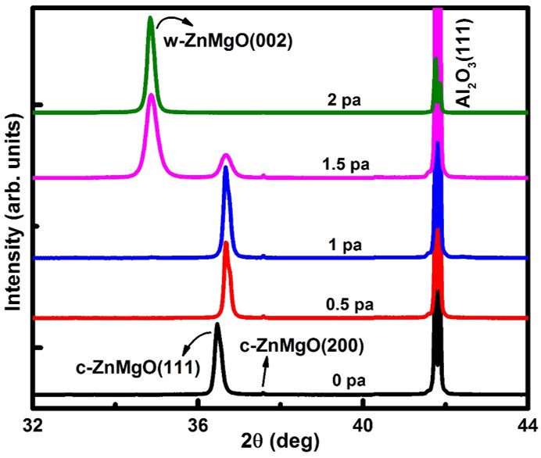

Figure 1. XRD analysis of ZnMgO thin films at different oxygen partial pressures.
Increase in PO₂ from 0 to 1.5 Pa cause a shift in (111) peak from 36.47° to 36.70°, which would be related to the Zn, Mg composition effected by the increase in PO₂. Mg and Zn contents are determined through EDX analysis. It has been observed that in ZnMgO thin films, Mg content are decreased with the increase in PO₂ as shown in figure 2. Mg is more active than Zn and thus can attract more oxygen atoms, so, at lower PO₂ oxygen atoms prefer to make a bond with Mg than Zn which increase the Mg concentration.
As the PO₂ increases, the binding process between Mg and O saturates steadily and thus allow more O atoms to bind with Zn and result an increase in Zn content in ZnMgO thin films. As Zn is more stable with hexagonal structure, so ZnMgO thin films with cubic structure have lower Zn composition while thin films with hexagonal structure have higher Zn composition.
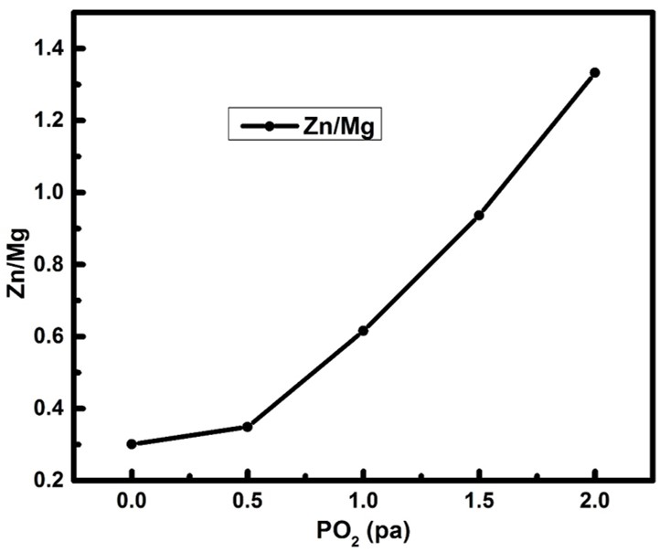

Figure 2. Zn, Mg ratio as a function of PO₂ in ZnMgO thin films.
Thermal vibration mode can be used to study the effect of PO₂ on crystal structure of ZnMgO thin films [10]. Collisions of Zn, Mg and O atoms with the induced oxygen gas (when they move from target to substrate during the growth of ZnMgO thin films) may result in the loss of their energy. Zn, Mg and O lose less energy due to their less collisions with induced oxygen gas at low PO₂, and have higher migration energy to reach the substrate surface. Thus more reactive atoms can easily reach to (111) and (200) surfaces [11]. In addition, at lower PO₂ the surface of substrate is covered by less oxygen atoms, so the deposited ZnMgO thin films are mainly oriented along (111) and (200) cubic directions. As both O and Zn(Mg) metal atoms constitute the (111) and (200) oriented cubic structure of ZnMgO thin films, so the O anions and Zn(Mg) cations would experience a strong repulsion from different types of ions during their migration within the (111) and (200) cubic surface of ZnMgO. Thus, ZnMgO thins films with (111) and (200) cubic structure showed identical composition and structure despite their high migration energy of reactive atoms [12].
Conversely, at higher PO₂, Zn, Mg and O atoms experienced more collisions with induced O atoms and result in an energy loss of Zn, Mg and O atoms to reach the substrate. So, a part of reactive atoms could not reach to (111) and (200) surfaces due to loss in migration energy. As the substrate has more O rich places, so, both cubic ((111), (200)) and hexagonal (002) grains are formed in ZnMgO thin films [13, 14]. Migration of reactive atoms between cubic ((111), (200)) and hexagonal (002) surfaces is much easier because they are consist of O or Zn(Mg) atoms and can exchange ions with the identical charge type [15]. So, in ZnMgO thin films grown at higher PO₂ of 1.5 Pa, the intense migration of O or Zn(Mg) metal atoms can give rise to composition and phase separation, thus ZnMgO grains are separated by ((111), (200)) cubic grains with lower Zn composition and (002) hexagonal grains with higher Zn composition. When the PO₂ further increased to 2 Pa, most of the reactive atoms don’t have enough energy to reach at the (111) and (200) cubic surfaces of ZnMgO, so ZnMgO thin films are deposited mainly along (002) hexagonal direction. Similar reports of the effect of oxygen partial pressure on the growth of SrTiO₃ and BaTiO₃ thin films were also reported [15, 16].
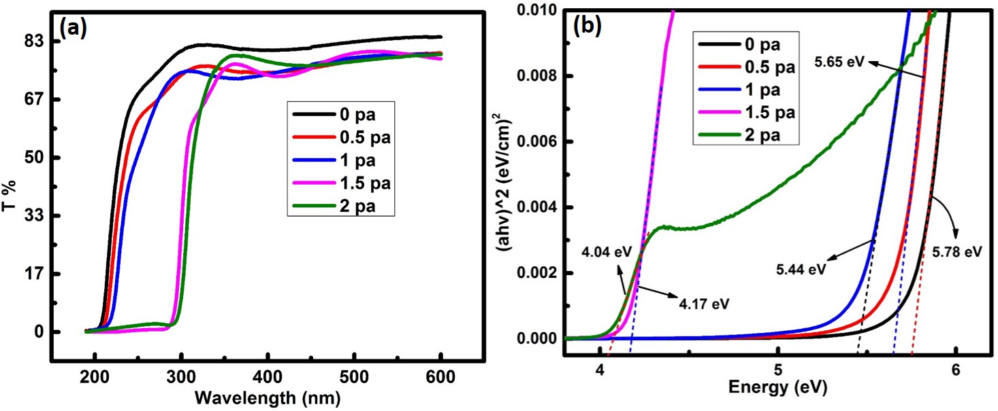

Figure 3. (a) Transmittance spectra and (b) optical band gap calculation of ZnMgO thin films.
UV-visible spectrophotometer has been used to study the effect of oxygen partial pressure on the optical band gap of ZnMgO thin films at room temperature. Contribution of sapphire substrate is excluded from the measurements. ZnMgO thin films are highly transparent and have the transmittance of ~82 % as shown in figure 3 (a). ZnMgO thin films have sharp absorption band edge which shift towards the shorter wavelength with the increase in Mg content. To calculate the band gap of thin films the absorption coefficient $α$ can be derived from the following equation:
$$α=A/{hv{\left(hv-E_{g}\right)}^{1/2}}$$
Where $A=log{(1}/{T)}$ is a proportional constant, T is a transmittance, $hv$ is a photon energy and $E_{g}$ is the band gap. ${(αhv)}^{2}$ was plotted against photon energy ($hv$), and band gap was calculated by the extrapolation of linear part at $α=0$. Figure 3 (b) shows the band gap values of ZnMgO thin films prepared at different PO₂. It can be seen that band gap of ZnMgO decreases by increasing PO₂, this conclude that ZnMgO thin films with higher Mg content have large band gap, conversely, thin films lower Mg content have small band gap. This type of behavior was also be depicted in other reports [17, 18].
Conclusion:
ZnMgO thin films were grown on sapphire substrate by PLD. It has been observed that growth environment strongly influenced the preferred orientation of thin films. At lower oxygen partial pressure cations and anions constituted the (111) and (200) cubic ZnMgO with higher migration energy of reactive atoms. At higher oxygen partial pressure, phase separation of ZnMgO occurred with higher migration energy of reactive atoms. Change in Zn, Mg composition with oxygen partial pressure also influenced the band gap of ZnMgO thin films. By adjusting the growth parameters, phase separation in ZnMgO thin films can be avoided, and single cubic ZnMgO thin films with higher Zn composition could be used in ultraviolet photo-electronic devices.

References
[1] Morshed, M.M., et al., Ultraviolet random lasing from asymmetrically contacted MgZnO metal-semiconductor-metal device. Applied Physics Letters, 2014. 105(21): p. 211107.
[2] Choopun, S., et al., Realization of band gap above 5.0 eV in metastable cubic-phase Mg x Zn 1− x O alloy films. Applied Physics Letters, 2002. 80(9): p. 1529-1531.
[3] Fan, M.-M., et al., Realization of cubic ZnMgO photodetectors for UVB applications. Journal of Materials Chemistry C, 2015. 3(2): p. 313-317.
[4] Zhu, H., et al., Low-threshold electrically pumped ultraviolet laser diode. Journal of Materials Chemistry, 2011. 21(9): p. 2848-2851.
[5] Ohtomo, A., et al., Mg x Zn 1− x O as a II–VI widegap semiconductor alloy. Applied Physics Letters, 1998. 72(19): p. 2466-2468.
[6] Vashaei, Z., et al., Structural variation of cubic and hexagonal Mg x Zn 1− x O layers grown on MgO (111)∕ c-sapphire. Journal of applied physics, 2005. 98(5): p. 054911.
[7] Segnit, E.R. and A. Holland, The System MgO‐ZnO‐SiO2. Journal of the American Ceramic Society, 1965. 48(8): p. 409-413.
[8] Makino, T., et al., Band gap engineering based on Mg x Zn 1− x O and Cd y Zn 1− y O ternary alloy films.
Applied Physics Letters, 2001. 78(9): p. 1237-1239.
[9] Liang, H., et al., Growth of single-phase Mg0. 3Zn0. 7O films suitable for solar-blind optical devices on RS-MgO substrates. Thin Solid Films, 2012. 520(6): p. 1705-1708.
[10] Lee, N.-Y., et al., Deposition profile of RF-magnetron-sputtered BaTiO3 thin films. Japanese journal of applied physics, 1994. 33(3R): p. 1484.
[11] Masuda, A. and K. Nashimoto, Orientation of MgO thin films on Si (100) and GaAs (100) prepared by electron-beam evaporation. Japanese journal of applied physics, 1994. 33(6A): p. L793.
[12] Chen, X., et al., Selective growth of (100)-,(110)-, and (111)-oriented MgO films on Si (100) by pulsed laser deposition. Journal of applied physics, 2002. 91(9): p. 5728-5734.
[13] Chen, X., et al., Growth of completely (110)-and (111)-oriented MgO films on H-terminated (100) silicon substrate by pulsed laser deposition. Applied surface science, 1998. 135(1-4): p. 233-237.
[14] Yoon, J.G. and K. Kim, Growth of (111) oriented MgO film on Si substrate by the sol‐gel method. Applied physics letters, 1995. 66(20): p. 2661-2663.
[15] Zhang, J., et al., Effect of oxygen pressure on the orientation, lattice parameters, and surface morphology of laser ablated BaTiO3 thin films. Thin Solid Films, 1996. 287(1-2): p. 101-103.
[16] Hiratani, M., et al., Growth of SrTiO3 thin films by pulsed-laser deposition. Thin Solid Films, 1993. 227(1): p. 100-104.
[17] Wang, X., et al., Optical properties of p-type ZnO doped by lithium and nitrogen. Solid state communications, 2007. 141(11): p. 600-604.
[18] Muthukumar, S., et al., Metalorganic chemical vapor deposition and characterizations of epitaxial MgxZn1− xO (0⩽ x⩽ 0.33) films on r-sapphire substrates. Journal of crystal growth, 2004. 261(2-3): p. 316-323.

